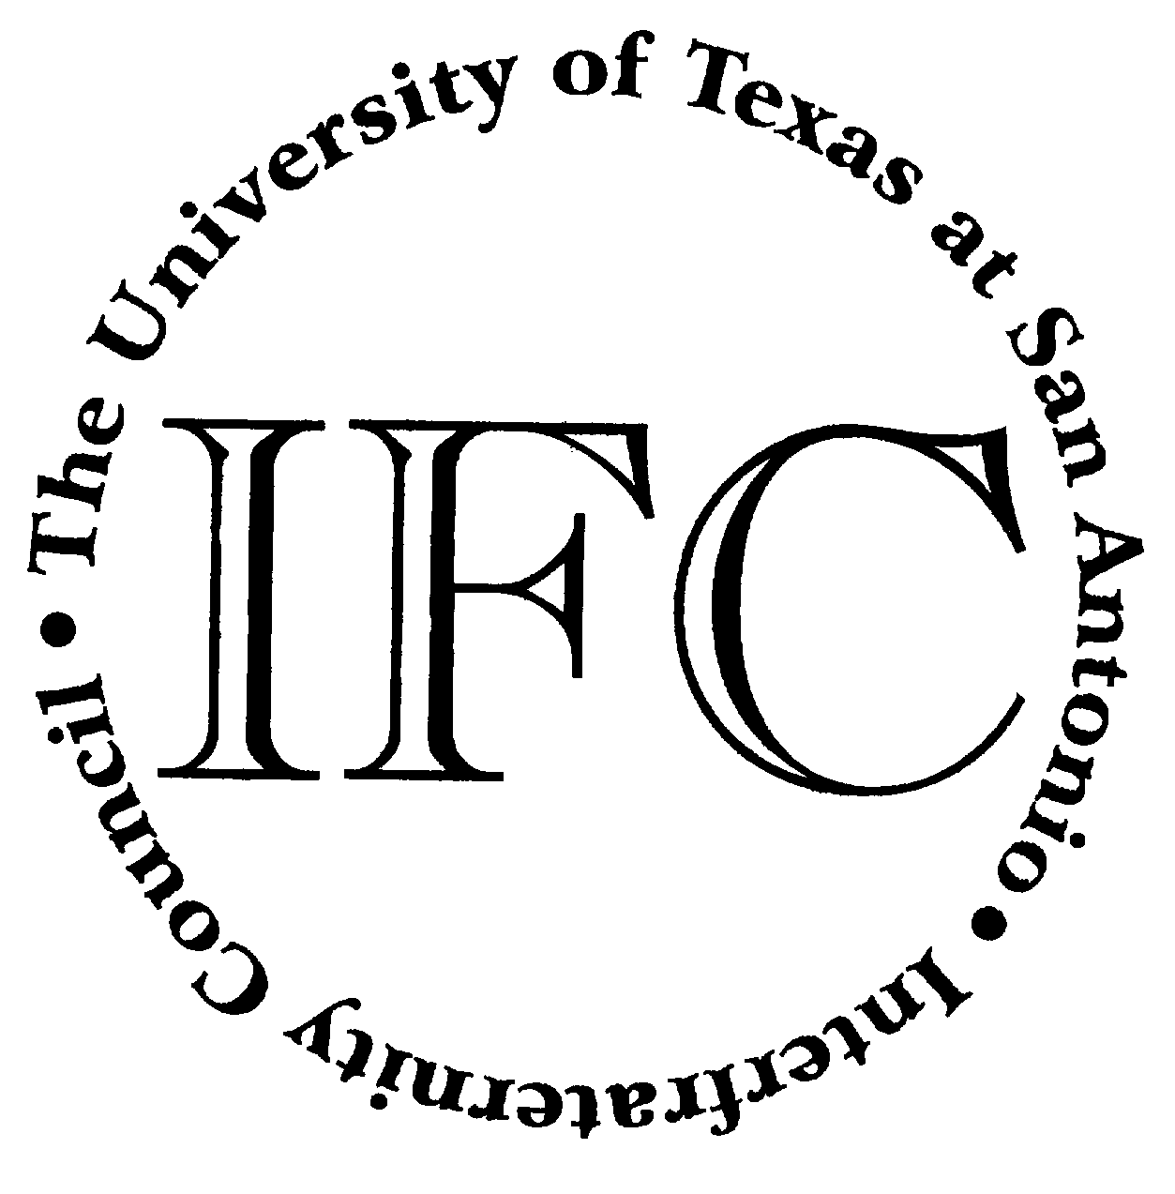
Student Activities Events For The Week Beginning April 2nd

Monday, April 2, 2007
Student Organization Summer/Fall Registration Begins
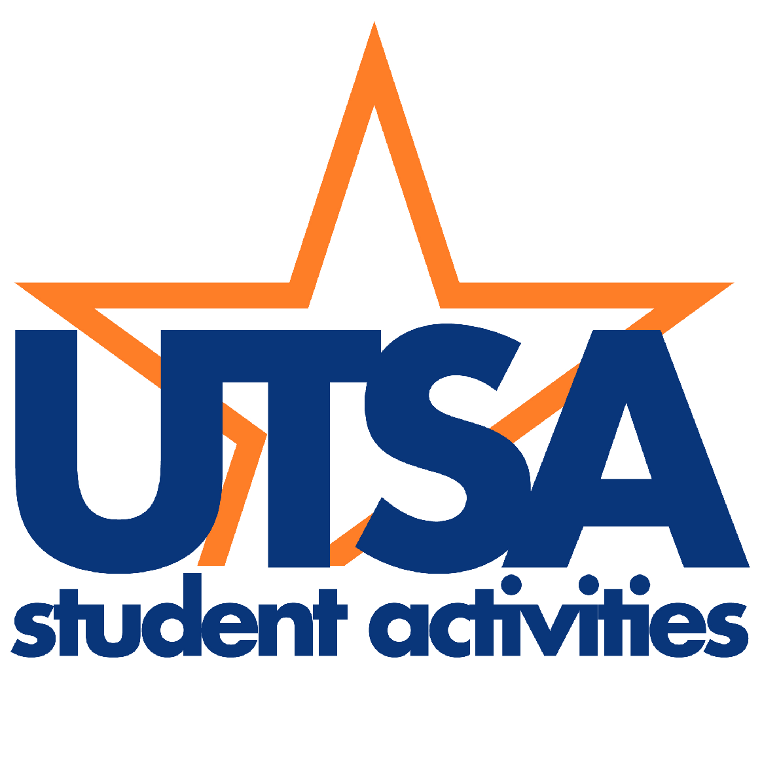
All forms are located on the Student Activities website.
1604/DT Campus
Student Activities
April 2 through 10th day of fall classes

Tuesday, April 3, 2007
Asian Pacific Islander Heritage
Month Kick-Off Event
Featuring the Filipino Student Association
1604 Campus
University Center- Window Lounge
12:15pm

Thursday, April 5, 2007
Downtown Asian Pacific Islander Heritage
Month Kick-Off Event
Durango Bldg. - Student Activities Center
12:30pm – 1:30pm

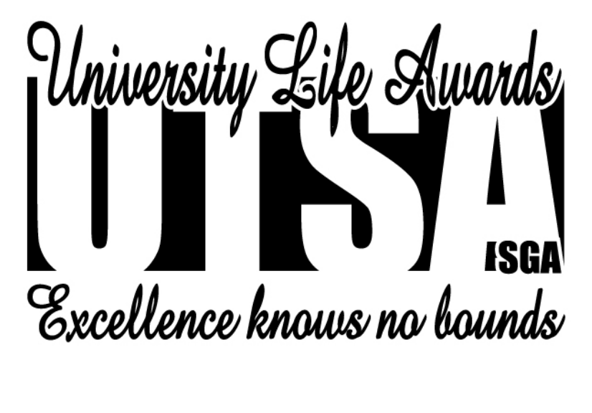

31st Annual University Life Awards
Awards Ceremony to Honor Those Outstanding Students,
Faculty, Staff, and Student Organizations
1604 Campus
University Center – Retama Auditorium
6pm
Please RSVP with Student Activities

April 2nd – 27th

Fortune Cookie Contest
Learn the history of the Fortune Cookie,
Guess Correct # and win all the cookies!
Students Only Please
Durango Bldg. - Information Desk
All Day

April is Asian Pacific Islander Heritage Month

