

**Searching for Contracts**

**__________________________**

**Using the Total Contract Manager System (TCM)**

Table of Contents

How to Search for Executed and Approved Contracts 2

When to Use Simple Search 2

When to Use Advance Search 3

How to Search for Contracts by Departments 4

Questions and Support 6

# **TCM Search Options**

Contract requests are submitted electronically using the Total Contracts Manager (TCM) system in Rowdy Exchange. This web-based tool streamlines the process by allowing you to track your contracts, monitor requests, access documents and collaborate more efficiently in one place.

**How to Search for Executed and Approved Contracts**

Use TCM to search for existing contracts, including those approved by the Business Contracts Office (BCO) and are still awaiting final signature. Begin your search by hovering over the TCM module (medal/ribbon icon). Under the **Contracts** section, click **Search Contracts**. There are two ways to search for a contract: Simple Search and Advanced Search.

**When to Use Simple Search**

Shown on the next page, a simple search is helpful if you’re searching for a certain contract and you know the basic contract information, such as title, number or summary. BCO recommends selecting the **All** option for the **Start/End Date field**.

After entering the information, click on the magnifying glass and TCM will show contracts meeting your search criteria. Click on the contract number to see the contract. For example, in the screen shot below, click on 2017‐30 if that is the contract you need.

**When to Use Advanced Search**

Select Advanced Search in the upper right corner to search using expanded field options.

The search function will look like this.

**How to Search for Contracts by Department**

To search for contracts under your department, use the **Work Groups** field. This field equates to what UTSA calls “department.” (The System does not allow modification of this title.)

Use the magnifying glass to expand fields such as **Work Groups, Contract Type** and **Contract Status.**

Use the black drop‐down arrowin the fields. DO NOT check the box until you get to the specific department field that you need. Click **Save Changes** and hit the **Search**button at the bottom of the Search screen.

After hitting the **Search**button, TCM will show those contracts meeting your search criteria. Click on the contract number (i.e., 2017‐30) to see the contract.

For additional viewing options, click on **Open Summary** on the right side of the screen.

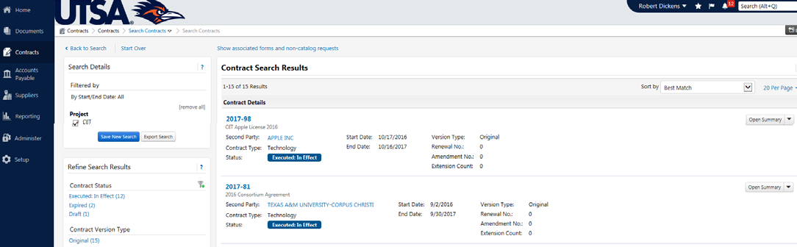

You can search using any of the options in Advanced Search in any combination, such as searching for a specific contract Typeand Statusfor your department (Work Groups).

**Questions and Support**

The Business Contracts Office is here to support you if you need assistance with TCM or have comments or questions. Email your requests to: [businesscontracts@utsa.edu](mailto:businesscontracts@utsa.edu).