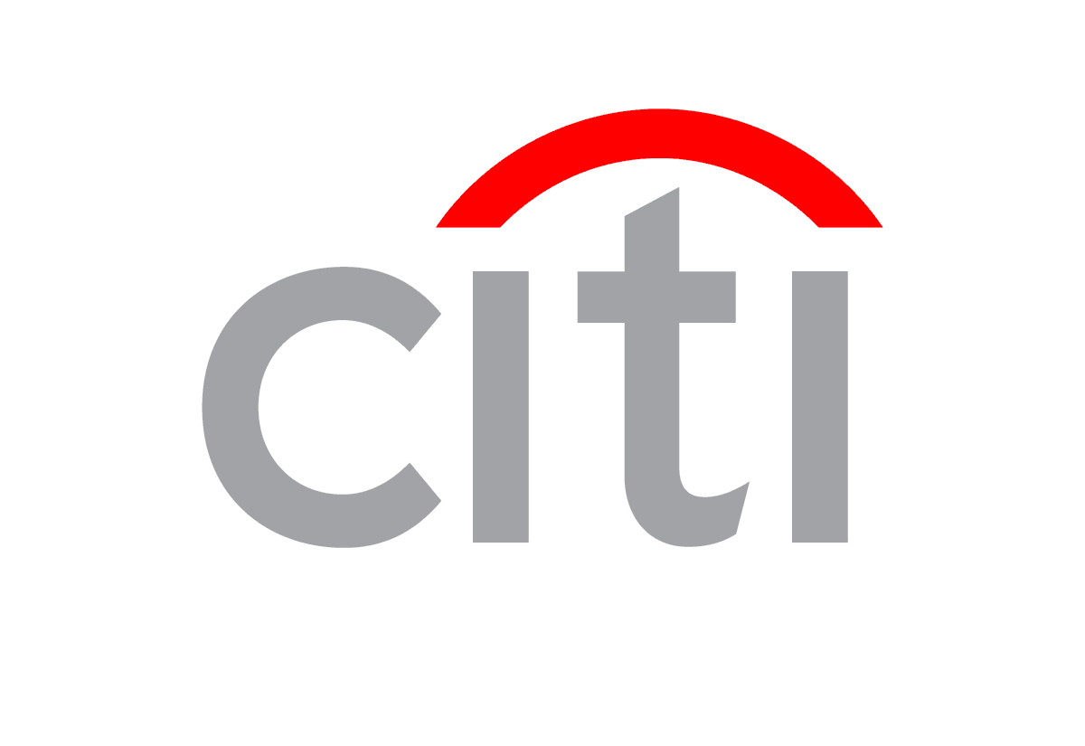
AFFIDAVIT OF UNAUTHORIZED USE

(Please return this Affidavit only if you are reporting unauthorized charges appearing on your statement.)

1. This affidavit concerns Citibank Mastercard/Visa Account Number
2. My business address is , in the City of
and the State of , Zip Code . Social Security Number
Business Phone # ( )
3. I HAVE INDICATED ON MY BILLING STATEMENT(S) THOSE TRANSACTIONS THAT ARE FRAUDULENT AND INCLUDED IT WITH THIS AFFIDAVIT.
4. Neither I, nor anyone authorized by me, nor anyone with my knowledge or consent received or expect to receive any benefit or value as a result of this transaction(s).
5. My account number was used in an unauthorized fashion. (Please describe):

a. Lost/Stolen. Date: Location: If Stolen Police Report Filed? Yes No
If Yes: City Precinct Case #
b. Never received.
c. All card(s) were in my possession at the time of the fraudulent use.
Other Circumstances:
6. I have reason to believe the following individual(s) utilized or had access to my account number without my authorization.
Name(s)
Address(es) Street Phone #( )
City State Zip Code
Reason:
- I understand that Bankcard Security investigates alleged fraudulent or unauthorized credit card usage and may refer the same to the appropriate law enforcement agency. I agree to cooperate in the prosecution of individuals charged with fraudulent or unauthorized credit card usage.
- The signatures set forth below are the signatures of ALL AUTHORIZED USERS on this account (continue additional authorized user signatures on the back):

PRINT NAME SIGNATURE

A FALSE DECLARATION TO A FEDERALLY INSURED FINANCIAL INSTITUTION MAY BE A VIOLATION OF FEDERAL AND/OR STATE LAW.

Fax or mail this document and the billing statement(s), which clearly indicate disputed transactions to Citibank:
Fax: 605-330-6801 Mail: Citibank USA, N.A.
Security Services
P.O. Box 6125
Sioux Falls, SD 57117

© 2008 Citibank (South Dakota), N.A. All rights reserved. Citi and Arc Design and Citibank are service marks of Citigroup Inc. or its affiliates, used and registered throughout the world.
CB015 1/1 Final 11/14/08

