Title: Use of Chloroplast DNA to Determine Maternity of Wild Callery Pear Trees

Location of the Work: Cincinnati, OH (University of Cincinnati)

Project Description
Many woody invasive plant species are of special concern because of their horticultural origin, having been purposely introduced and sold throughout the US. In our laboratory, we are interested in invasive populations of the ornamental tree, Pyrus calleryana (Callery pear), which was introduced from China in the early 1900's and is now one of the most popular landscaping trees in the US. It is now in the spread stage, a point at which control efforts can potentially be the most effective.

Previous research in our laboratory using nuclear microsatellite markers has established the hybrid origin of individuals in invasive populations in the eastern US. These hybrids formed following cross-pollination between genetically different cultivated varieties (cultivars) of P. calleryana (e.g. 'Bradford' and 'Chanticleer') planted in neighboring residential and commercial areas. Although nuclear markers have been informative in determining the responsible parents for each wild tree, they cannot be used to further indicate which of the pair is the maternal (seed) or the paternal (pollen) parent. This information, if known, would be effective in identifying particular cultivars that are more likely to be seed or pollen parents of invasive individuals, thus enabling control efforts to focus on these cultivars. In this study, we will use maternally-inherited chloroplast DNA markers to identify the maternal parent of hybrid individuals, with the remaining parent as the paternal contributor. This method has been highly effective in parentage studies of animals using mitochondrial DNA, but has generally been limited in plants because of low variation in chloroplast regions. This will be addressed in the current study by using variable microsatellites located primarily in non-coding regions of chloroplast DNA containing mononucleotide (e.g. [A]₈) or dinucleotide repeats (e.g. [AT]₄[CA]₄). We have already identified 11 mononucleotide and two dinucleotide repeats in regions including the trnL-trnF intergenic spacer region and genes such as NADH dehydrogenase F, matK, rpl16, and rpS16.

To conduct this project, we will extract chloroplast DNA from leaves of 300 F₁ hybrid wild trees which have already been genotyped with nuclear microsatellite markers. Leaf samples from 15 known cultivars of P. calleryana will also be analyzed to determine their chloroplast DNA genotype. All samples will be subjected to PCR to amplify specific chloroplast regions and these PCR products will be sequenced. Genetic analysis will use the matching algorithm of the GenAlex software program to compare the chloroplast DNA genotype (i.e. microsatellite repeat number) of each wild individual against those of their parents (as previously determined with nuclear microsatellites). A match between the genotype of a wild individual with one of its parents will confirm that the latter is the seed parent. The final step will be to use a one-way analysis of variance to determine if any single cultivar produces more invasive offspring as either a seed or a pollen parent, than any other cultivar. If so, this will indicate a point of focus for control efforts. Consequently, participants in this project will learn a variety of techniques, including field sampling, DNA extraction, PCR, and sequencing analysis.

Contact Information:
Dr. Theresa Culley
Associate Professor
Department of Biological Sciences
University of Cincinnati
614 Rieveschl Hall
Cincinnati, OH 45221-0006
Tel: 513-556-9705
Email: theresa.culley@uc.edu
Web: http://www.biology.uc.edu/faculty/culley/theresa.html

Images for Posting:

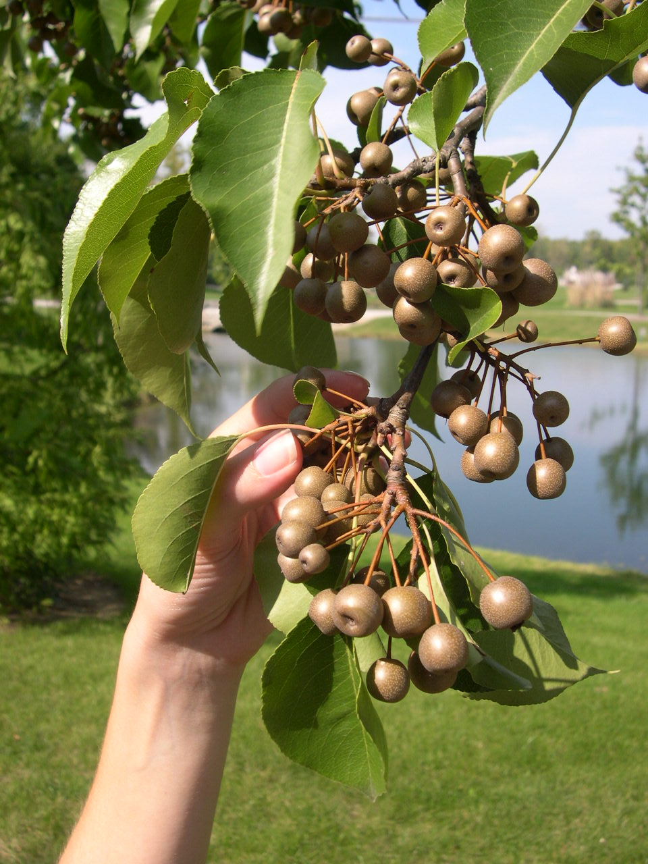

Caption: Fruits of cultivated Callery pear trees are often dispersed by birds to nearby natural areas where the seeds germinate, resulting in the creation of invasive populations.

Additional Information:
Low cost housing to FaST members is available through either the university as well as at nearby Xavier University. The University of Cincinnati also offers a summer Women in Science and Engineering (WISE) program for female undergraduate students. This is a competitive program in which students partner with faculty members and also attend weekly workshops to enhance professional development. Any female undergraduate on the FaST team could also apply for this program.

