Title: Ecosystem management of regionally abundant, invasive plants in an era of global environmental change

Location:
- Laboratory work will be conducted at a research facility on the east campus of the University of Colorado in Boulder, CO.
- Field work will take place in experimental gardens and in the foothills of the Rocky Mountains northwest of Boulder in grasslands and Ponderosa pine savanna.

Project Description:
Weed management of pastures and rangelands must be focused into a forward-looking, adaptive framework that acknowledges how changing environmental drivers affect or interact with management actions. Land managers along the Colorado Front Range of the Rocky Mountains identify four invasive weeds as among their highest priority for management: diffuse knapweed, cheatgrass, Dalmation toadflax and Canada thistle. Using field experiments and spatial ecological-economic modeling, this project tests and implements management strategies for these regionally abundant, economically important rangeland weeds, and develops educational and outreach programs to emphasize the rationale and science facts behind sustainable management actions.
We envision the FaST student and faculty team collaborating with us on both field experiments and an educational/outreach activities targeting the management of annual bromes (Bromus tectorum and B. japonicus). Skills acquired through these experiments would include elements of experimental design, field sampling, and vegetation analyses as well as chemical analyses of soil samples and resin bags for inorganic nitrogen in the lab. Depending upon the interests and time available to the team, several additional experiments and activities are possible.
Field experiments:
Our current research project involves experiments that test how grazing and plant competition for soil resources affect cheatgrass success when applied at non-traditional but key phases of growth. We also seek to determine whether any local shifts in the growing season from a summer-wet pattern have strengthened the ability of these annual bromes to alter soil regimes and out-compete native perennial warm and cool-season grasses for water and nitrogen.
We would begin collaboration with the FaST team prior to their 10-week research period in order to develop additional research questions and collaborate on new experimental field treatments to supplement currently proposed research activities. The early-season rapid and opportunistic growth of these annual grasses requires that we work with the FaST members to time our field experiments accordingly. Thus, we will initiate the FaST team’s plot manipulations in the spring, prior to the arrival of the FaST team. We envision that the FaST team could then survey, collect, and analyze data from field plots in the lab during the 10-week study period. We propose a new dimension (not currently proposed in our research) for the FaST effort: responses of the weed to nitrogen manipulations under the grazing and competition manipulations currently planned for the study.
In a similar vein, new research that evaluates the success of Canada thistle across a resource and plant completion gradient is proposed that would benefit from a FaST assessment project. In addition, we have experiments underway on two species of knapweed and Dalmation toadflax that would benefit from additional measurements on factors affecting the efficacy of biological control agents.
Education/Outreach:
We would like to collaborate with the FaST team to generate a high quality educational component that conveys the message of a need for management of regionally abundant, non-native species with respect to environmental change. We also envision working with the FaST team to present our project and preliminary research data at a local monthly meeting of the Colorado Weed Management Association.

Contact Information:
Dr. Timothy Seastedt
Institute of Arctic and Alpine Research
University of Colorado
Campus Box 450
Boulder, CO 80309-0450 USA

Website:
Seastedt laboratory: http://culter.colorado.edu/~tims/
University of Colorado: www.colorado.edu
INSTAAR (research lab): http://instaar.colorado.edu/index.html

Additional Information:
Projects should be initiated no later than 1 June. The lab will assist the FaST participants in obtaining housing for the two-month interval.

Images:

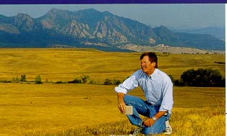
Tim Seastedt (PI) in prairie with Boulder
and foothills in background

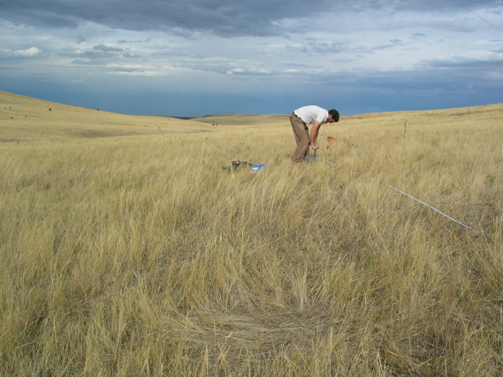
David Knochel (co-PI & ecology doctoral student) collecting samples near Boulder, CO

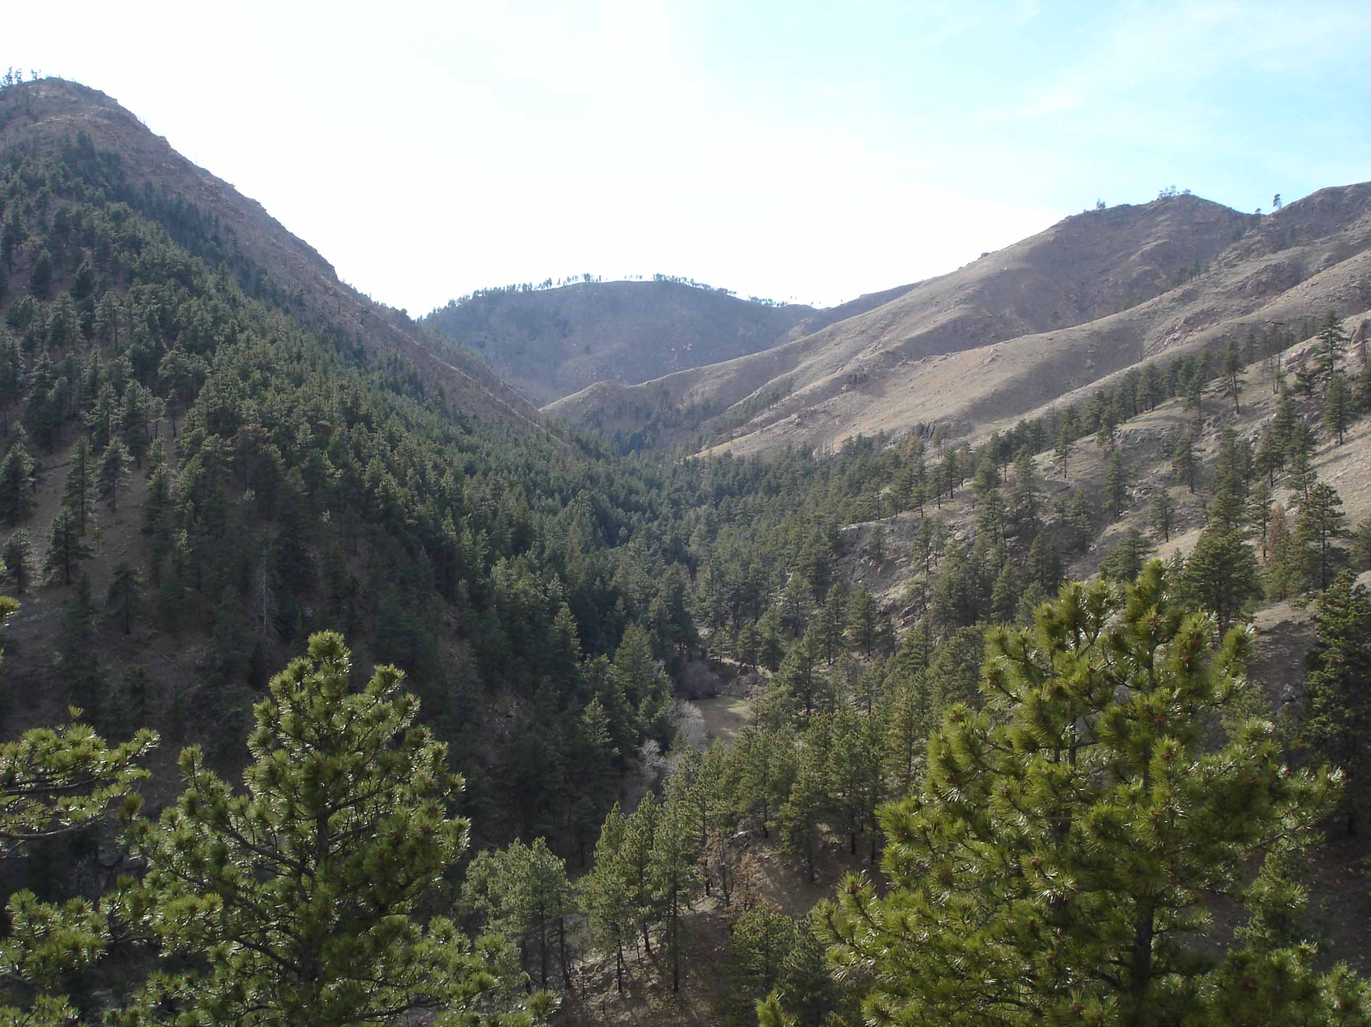

Left Hand Canyon field site for annual brome experiments

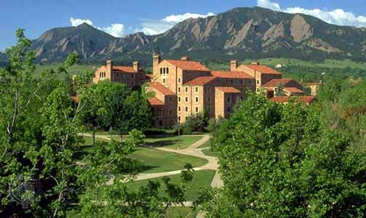
University of Colorado at Boulder campus

