ECOSYSTEM RESPONSE TO INVASIVE SPECIES
John Cardina, Ohio State University, 330-263-3644, cardina.2@osu.edu

Location of the Work
Ohio State University’s Ohio Agricultural Research and Development Center (OARDC), Wooster Ohio, the research branch of the College of Agriculture. Field sites are located in Ohio and southern Michigan.

Project Description
What happens to an ecosystem when an invasive insect destroys an entire plant genus? The emerald ash borer (EAB), an exotic invader, is destined to kill every species of ash tree (genus Fraxinus) in eastern North American forests. This could initiate a cascade of changes in plant, animal, and microbial communities; soil and water chemistry; and ultimately forest health and ecosystem stability.
Our goal is to understand how ecosystems respond to wide-scale disturbance by studying changes in native and exotic organisms in forests impacted by the EAB invasion. We have been studying the establishment, growth, and reproduction of invasive plants in EAB-impacted forests. In addition, students, post-docs, and visiting scholars have initiated studies on other key species, such as ground beetles and woodpeckers.

We are excited to work with FaST faculty and students to develop short- and long-term projects in their areas of interest. Possibilities include:
- Use of dead ash trees by wildlife.
- Effects of dead ash gaps on litter-dwelling organisms (amphibians, insects, etc).
- Distribution of invasive earthworm species (and possible effects on native and invasive plant responses to disturbance).
- Using dendrochronology to examine responses of native and/or invasive woody species.
- Response of woodpecker and other bird species.
- Identification of EAB parasitoids.
- Effects of ash mortality on carbon cycling.
- And many more!

FaST partners will have the opportunity to explore new areas of research within plots established for our ongoing projects, allowing them to learn new techniques and skills, including:
- Identification of plants, insects, birds, amphibians, nematodes, or other critters of interest.
- Methods for evaluating tree canopy health.
- Techniques to measure distribution and abundance of plants, insects, birds, amphibians etc.
- Use of densiometer, light meters, hemispherical photography, and other tools to measure understory light environments.
- Soil sampling and characterization techniques.
- Dendrochronology and other methods to determine forest age and history.
- Use of GIS to analyze landscape attributes affecting forest response to EAB invasion.

We have established 260 monitoring plots at 82 forest sites in Ohio and Michigan, across a gradient of emerald ash borer infestation. Stands range from un-infested healthy stands to “aftermath” forests with >99% mortality of ash trees. Sites include riparian areas, upland forests, and swamps to encompass all five ash species that occur in the region. These study sites provide many opportunities for research where a diverse group of undergraduates, graduate students, post-docs, OSU faculty, and US Forest Service researchers is conducting research. For example, in 2007 three undergraduates conducted individual research projects and will present posters on their research at regional research conferences. Numerous other posters and presentations have resulted from research in these monitoring plots, and several publications are in being published or are in preparation.

Contact Information
John Cardina cardina.2@osu.edu
Department of Horticulture and Crop Science
1680 Madison Ave.
Wooster, OH 44691

Dan Herms herms.2@osu.edu
Department of Entomology
1680 Madison Ave.
Wooster, OH 44691

Kathleen S. Knight ksknight@fs.fed.us
USDA Forest Service Northern Research Station
359 Main Road
Delaware, OH 43015

Links to Laboratory and Project Web-sites
http://ashalert.osu.edu/studentresearch

Additional Information
Low cost housing for visiting scholars is available on campus for FaST members, within an easy walk to the office and lab. FaST scholars will have access to excellent laboratory, field, computer, and library facilities on campus.
We have an excellent record of experience with visiting scholars from several universities including Escuela Agricola Panamericana Zamarono in Honduras. Zamarano scholars work in departments of Entomology, Plant Pathology, and Horticulture & Crop Science. About 80% of these scholars have continued towards their MS or PhD programs.
The Ohio State University has been named as one of the top employers according to a Chronicle of Higher Education survey. The university was recognized as a top-five employer in five of the publication's survey categories, including compensation and benefits, confidence in senior leaders, health insurance, housing assistance programs and life insurance. Ohio State offers a comprehensive health benefit package with a variety of options to meet individual needs. Visiting scholars are required to obtain insurance through Ohio State University or Midwest Select.
Wooster, Ohio is a suburban community of 26,000 in northeastern Ohio. The city and surrounding region offer plenty of opportunities for recreation and relaxation, and combine the best of city and country living. Wooster is a growing business community. Each year brings new restaurants, stores and other businesses to the area, so great shopping and the latest movies are only a few minutes away.

Images of our project:
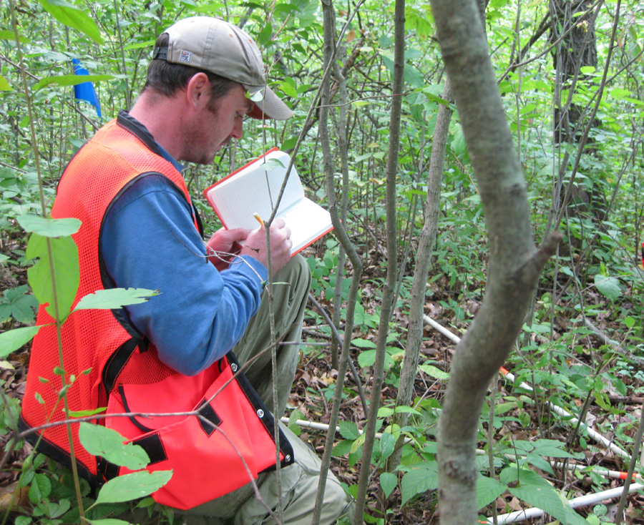Kevin records data on giant swallowtails and prickly ash.
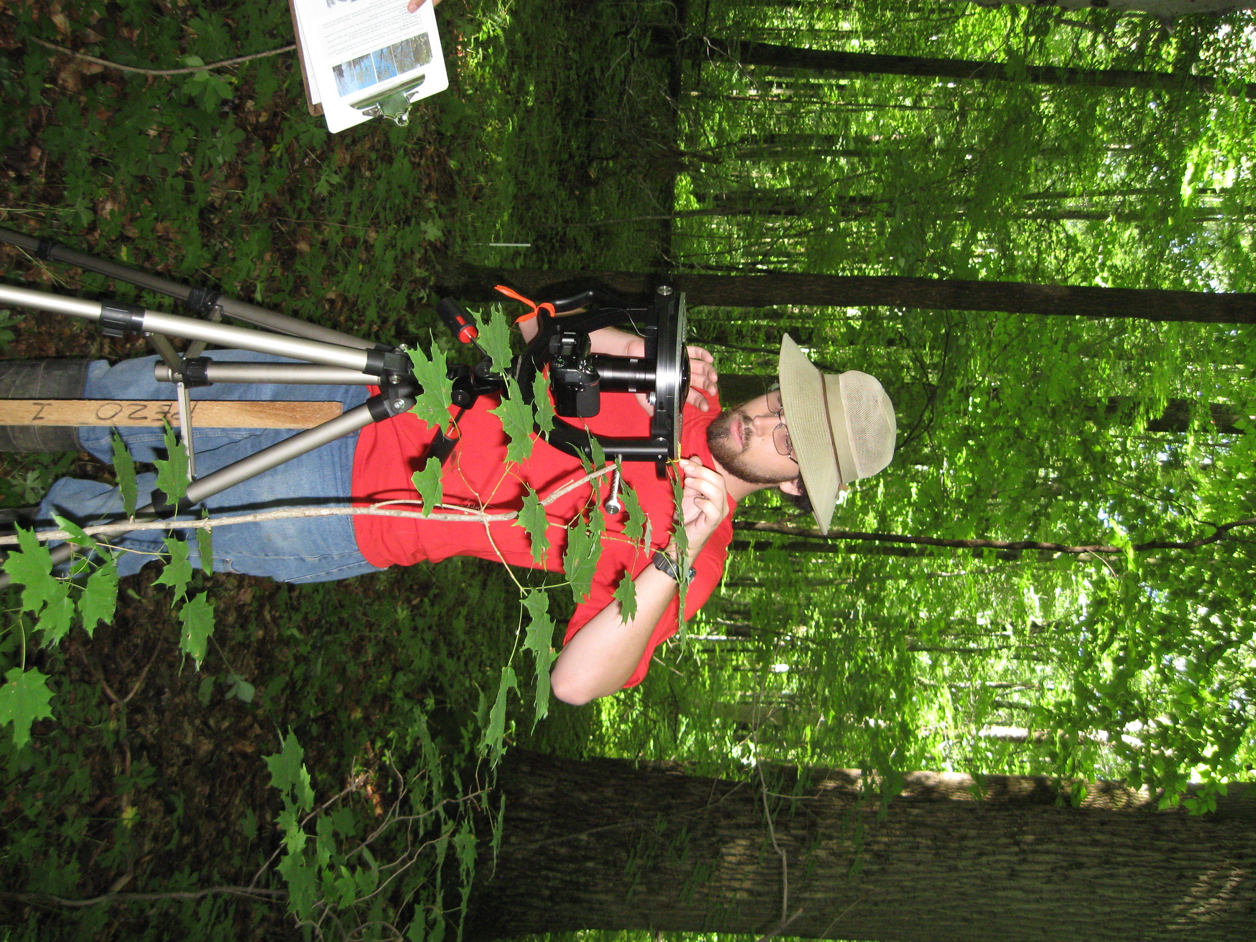Nathan levels the camera for hemispherical photographs of the forest canopy.
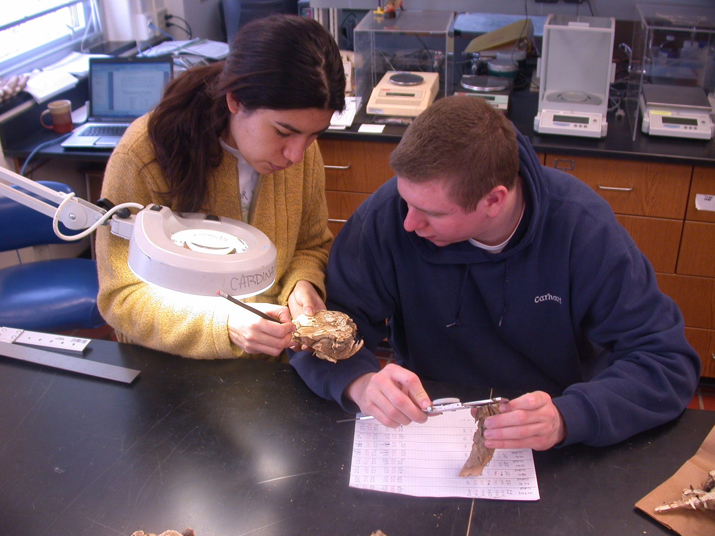
Elena, visiting scholar from Ecuador, shows Leland how to count annual growth rings in invasive bush honeysuckle.
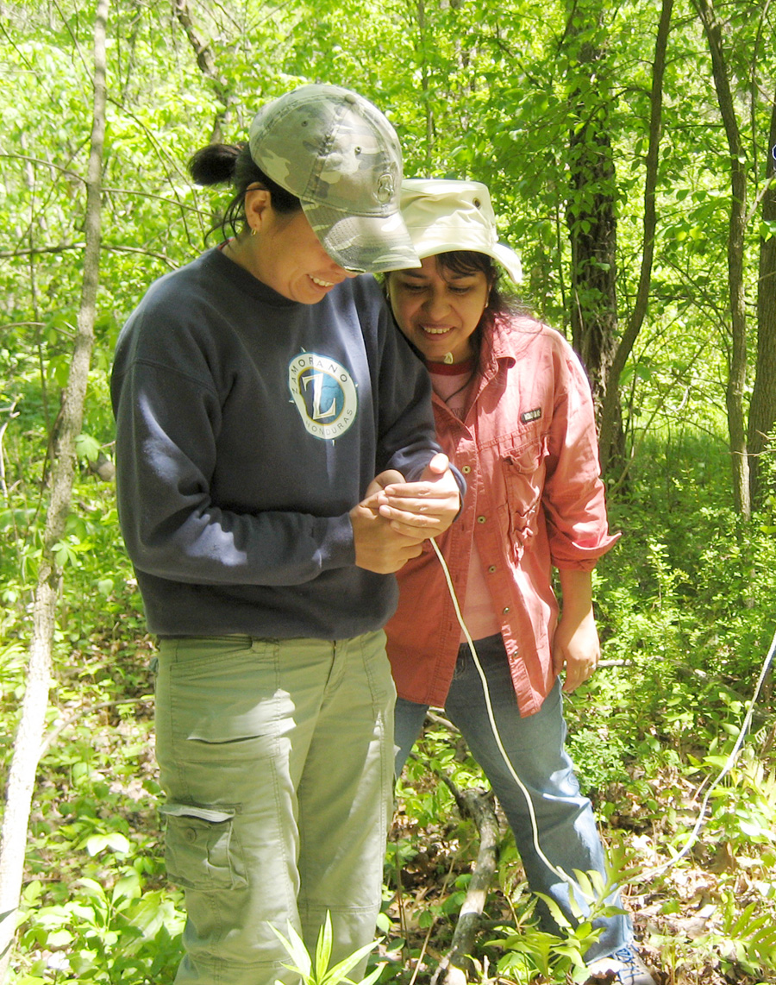
Allie (visiting scholar) and Kamal (post-doc) check settings on a canopy sensor.
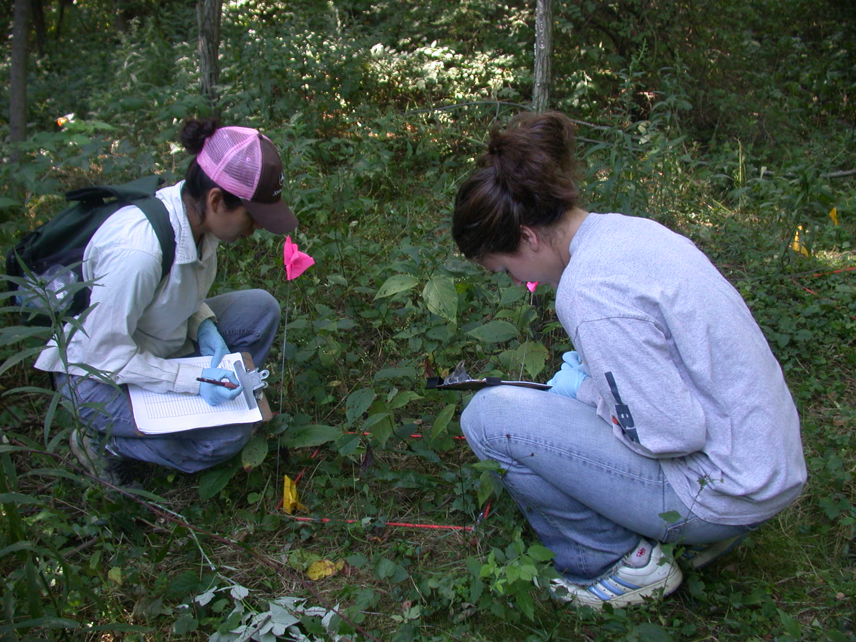
Elena and Stephanie collecting data on native plants in the forest understory.

