EVENT - EMERGENCY ACTION PLAN (E-EAP)
Texas Folklife Festival (EXAMPLE)
THE UNIVERSITY OF TEXAS AT SAN ANTONIO | 2023 | V.1

TABLE OF CONTENTS
I. RECORD OF CHANGES 2
II. INTRODUCTION 3
III. AUTHORITY 3
IV. DEVELOPMENT, IMPLEMENTATION, & MAINTENANCE 3
V. UTSA EMERGENCY CONTACTS 3
VI. GENERAL SAFETY REMINDERS 4
VII. FIRE / EVACUTION 4
Persons Requiring Evacuation Assistance 5
VIII. SHELTER IN PLACE 6
IX. UTILITY FAILURE 6
X. HAZARDOUS MATERIALS 7
XI. SEVERE WEATHER 8
XII. ACTIVE THREAT / PERSON WITH A WEAPON 8
XIII. MEDICAL EMERGENCIES 9
XIV. AFTER THE EMERGENCY 10
XV. ORDER OF SUCCESSION 10
APPENDIX 1: EVENT INFORMATION 11
APPENDIX 2: PERSONNEL ROSTER / PHONE TREE 12
APPENDIX 3: SPECIFIC STAFF ASSIGNMENTS 13
APPENDIX 4: EVENT MAP 14
APPENDIX 5: EVACUATION ASSEMBLY POINTS 15
APPENDIX 6: ADDITIONAL TRAINING RESOURCES 16
UTSA Classroom Training 16
Incident Command System Training 16

RECORD OF CHANGES
CHANGE | DATE | EDITED | APPROVED
Plan Development - EXAMPLE | Aug 2023 | C. Garcia

INTRODUCTION
The [Event Name / Location] Emergency Action Plan (E-EAP) is an all-hazard plan that details the emergency procedures specific to the [Event Name]. The purpose of the plan is to ensure the safety of the students, faculty, staff and visitors of the [Event Name / Location] in the event of an emergency. This plan has been developed to improve the efficiency of the response to an incident in an effort to foster a culture of safety.

AUTHORITY
The UTSA President, or an official designee, is responsible for the approval of changes to the operational status of the university and will make appropriate decisions concerning the discontinuation of university functions, cancellation of classes or the cessation of specific operations such as events.

DEVELOPMENT, IMPLEMENTATION, & MAINTENANCE
The Office of Risk and Emergency Management (OREM) has developed this plan template which is to be modified and maintained by the [Event Name] organizers responsible for the event. This plan is supplemental to UTSA’s Comprehensive Emergency Management plan and should be updated and reviewed prior to each event. Changes to this plan should be notated on the Record of Changes table on page 3. Distribution of this plan to appropriate stakeholders is the responsibility of the [Event Name] organizers. This plan may be submitted for review to OREM upon the discretion of [Position Title], the plan owner.

UTSA EMERGENCY CONTACTS
Safety Resources:
- UTSA Police/Fire/Rescue/Hazmat: (210) 458-4911 (from UTSA phone: 911)
- UTSA Police Non-Emergency: (210) 458-4242
- UTSA Risk & Emergency Management: (210) 458-5250
- UTSA Lab Safety: (210) 458-6230
- UTSA Facilities Operations: (210) 458-5277

Counseling and Health Services:
- Students - Wellness 360: (210) 458-4142
- Employees – Employee Assistance Program: (888) 993-7650

GENERAL SAFETY REMINDERS
Be aware of your surroundings. Awareness is your best defense. Know what is happening around you. Be especially careful and alert if you are alone. Watch where you are going and what is going on around you. Look for potential problems and be prepared to react to them. Avoid going to secluded areas.
Trust your instincts. If it doesn't feel right, it probably isn't. Whether alone or in a group, if you think something is wrong, remove yourself from the situation. Don't be afraid to report your suspicions.
When walking, plan the safest and most direct route. Use well-lit, busy streets, sidewalks and pathways. Walk with friends or a group, especially at night. Always let someone you trust know where you will be going, how you will be getting there and when you plan to return. Avoid areas you are not familiar with, alleys, deserted streets, and secluded and wooded areas.
If you are being followed or feel threatened, be proactive. Cross the street, change direction and go to a safe, busy and well-lit area where you can ask for help or call the police. If a car is following you, turn around and walk in the opposite direction if possible. Write down the license plate number and a description of the car and occupants.
Report suspicious activity. Criminals do not want to be seen or heard. We rely on the community to report suspicious activity. Police would much rather respond to you and not be needed than not be called when a crime could have been prevented or stopped. Trust your instincts; if something does not feel right, it probably isn't – report it!
Register for UTSA Alerts to receive emergency notification text messages. Login to ASAP and click on UTSA Alerts under the Personal Information tab. Guest/visitors can Text “UTSAGuest” to 226787. Guest registration expires after 60 days, or reply “STOP UTSAGuest” to cancel.
Program the UTSA Police number in to your phone. On UTSA campuses, our police department can respond to emergencies much faster than local law enforcement. Call (210) 458-4911 for emergencies and (210) 458-4242 for police assistance with non-emergencies.

FIRE / EVACUTION
As with any emergency, the best advice is to be prepared by familiarizing yourself with evacuation route plans. See Appendix 3 for additional information and a map of your Evacuation Assembly Points (EAPs).
In the event of a fire:
- Pull the nearest fire alarm and leave via the preplanned evacuation route if safe to do so.
- Dial (210) 458-4911 or 911 (from UTSA phones) and give your name and location of the fire. (If necessary, dial 911 from another building.)
When a fire alarm sounds, occupants/attendees should:
- Proceed immediately to an exit and move a safe distance away from the building. If the primary exit is blocked, choose the best alternate route. If time permits, close doors and windows behind you.
- Do not use an elevator.
If there is smoke in the area, remain close to the floor:
- Before passing through any door, feel the metal doorknob. If it is hot, do not open the door. Before opening a door, brace yourself against it slightly; if heat or heavy smoke are present, close the door and stay in the room.
- If you cannot leave the room:
  - Open the windows.
  - Seal the cracks around doors with clothing or other material, soaked with water if possible.
  - Hang an object (bedsheet, jacket, shirt, etc.) out the window to gain attention.
  - Shout for help.
  - If possible, call (210) 458-4911 or 911 (from UTSA phones) and report that you are trapped.
  - If all exits are found to be blocked, go to a room as far as possible from the fire, close the door, and the follow the above procedures.

Persons Requiring Evacuation Assistance
Assisting Blind/Visually Impaired:
- Clearly announce the type of emergency.
- Offer your arm for guidance.
- Tell the person where you are going, and alert him/her to obstacles along the way.
Assisting the Deaf/Hearing Impaired:
- Turn lights on and off to gain the person's attention.
- Indicate directions with gestures or written note.
Mobility Impaired:
To assist those requiring evacuation assistance, engage in the following:
- Call UTSAPD at (210) 458-4911 if someone is immobile and needs additional assistance evacuating.
- Do not use elevators.
- Seek volunteers to assist students/personnel with physical disabilities to the nearest enclosed stairway or designated areas for rescue assistance.
- One individual should remain with the person(s) if it can be done without unreasonable personal risk. If the hazard becomes life-threatening (i.e., fire is getting close or the smoke becomes a choking hazard) move the individual into a room and close the door. Vacate the building.
- Others should advise emergency personnel of the location so that the evacuation can be completed.
If you are unable to evacuate a building safely because of your inability to use an elevator and you do not have an evacuation plan, look for a member of the event staff and make your need for assistance known. If event staff is unable or unavailable to assist, please secure yourself in an enclosed exit stairwell, note the location of the stairwell (i.e. S-1, S-2, etc.), call UTSA Police immediately with your location, and if other people are present when the emergency occurs, ask someone to send help for you.

SHELTER IN PLACE
Guidelines:
- Seek shelter immediately in any campus building away from windows. If you are in a building, remain there. If not, go inside immediately. Close all doors and windows.
- If you are in a vehicle at the time of the notification to protect in place, you should close doors and windows, turn off your heating or air conditioning, and then drive out of the at-risk area or to a building you can enter for protection.
- Remain calm, conserve your energy, and wait for notification that all is clear.
For outdoor events, designated Shelter-in-Place locations: [Building 1] and [Building 2].

UTILITY FAILURE
Utility Failure:
In case of utility failure (electricity, water, gas) call UTSAPD at (210) 458-4911 or 911 (from UTSA phones).
If trapped in an elevator, call UTSAPD with the following information:
- Building name.
- Floor number.
- Room # (if applicable).
- Nature of problem.
- Person or telephone extension to contact.
Remain in place until notified. Individuals in corridors and exit stairs should evacuate while emergency lights are on. Emergency lighting is temporary and is not provided to continue building operations.
Electrical Outage:
- Evacuate the building if the fire alarm sounds or upon notification by authorized emergency personnel.
- In laboratory buildings, fume hoods do not operate during a power outage. Do not use laboratories until the ventilation is properly restored.
Gas Leak / Unusual Odors:
- Cease all operations immediately.
- Do not use cell phones or other electronic equipment.
- Do not switch lights on or off.
- Evacuate as soon as possible.
Flooding / Plumbing Failure:
- Cease using all electrical equipment.
- Avoid contact with the water.
- Evacuate the building if necessary.

HAZARDOUS MATERIALS
General Instructions:
- Placards are posted outside all rooms containing hazardous materials or equipment.
- Notify the UTSA Police Department at (210) 458-4911.
- Isolate the area - do not touch, taste or smell the material.
- Notify people in the neighboring offices and classrooms, and evacuate.
Chemical Spills:
Detailed safety procedures are in place in all campus laboratories where dangerous materials are used and stored. If you encounter a chemical spill:
- Turn off space heaters and extinguish open flames in the area if it is safe to do so.
- If there are vapors or noxious fumes, evacuate the affected area or building and do not re-enter the area until authorized emergency personnel give the “all clear signal”.
Radioactive Materials:
- Radioactive materials are utilized in some campus laboratories. Those that might be encountered are considered low-level sources of radiation and pose minimal threat when properly stored and handled.
- If you believe that you or others have come into contact with radioactivity on your skin, clothes or shoes, remain in the area at a safe distance until checked and cleared of radioactive contamination by safety office personnel.

SEVERE WEATHER
Weather closure information:
UTSA’s Office of Risk and Emergency Management monitors weather and can serve event organizers in an advisory capacity. Information regarding weather closures at UTSA is available via a variety of resources:
- UTSA Today
- The university's official social channels on Twitter, Facebook and Instagram.
- If necessary, information will be sent via UTSA Alerts through text, voice or email. Always ensure your personal contact information on ASAP is up to date.
- Local media: News of university closings are broadcast via radio and television stations throughout the region.
Tornado or severe thunderstorm watch: conditions are favorable for development. Continue normal activities but monitor local weather conditions. Use good, independent judgment.
Tornado or severe thunderstorm warning: the watch may be elevated to a warning if the severe weather poses an immediate threat to the area. Take the following steps:
- Notify the building occupants, or event attendees, of the weather warning.
- If a thunderstorm warning, stay indoors and away from windows until the storm passes.
- If it is a tornado warning, you should seek shelter immediately.
- If you are in a vehicle, get out and seek shelter in a sturdy building. If a building is not available, a depression such as a ditch or ravine offers some protection.
- Basements, interior hallways/rooms, and bathrooms on the lower floors with no windows or exterior walls, offer the best shelter.
- Immediately report any injuries to the UTSA Police Department at (210) 458-4911.
- Immediately leave a badly damaged building and do not attempt to return to the building until directed to do so.
- Do not attempt to turn utilities or equipment on or off.

ACTIVE THREAT / PERSON WITH A WEAPON
During an act of violence (e.g. robbery, hostage situation, workplace violence, active shooter): AVOID, DENY, DEFEND.
AVOID starts with your state of mind.
- Pay attention to your surroundings.
- Have an exit plan.
- Move away from the source of the threat as quickly as possible.
- The more distance and barriers between you and the threat, the better.
DENY when getting away is difficult or impossible.
- Keep distance between you and the source.
- Create barriers to prevent or slow down a threat from getting to you.
- Turn the lights off.
- Remain out of sight and quiet by hiding behind large objects and silence your phone.
DEFEND because you have the right to protect yourself.
- If you cannot AVOID or DENY, be prepared to defend yourself.
- Be aggressive and committed to your actions.
- Do not fight fairly. THIS IS ABOUT SURVIVAL.
COMPLY with first responders.
When and if it is safe to do so, call UTSA Police Department at (210) 458-4911 (from UTSA phones: 911). Tell the dispatcher:
- Location of active shooter(s).
- Number of shooters.
- Physical description of shooters.
- Number and type of weapons shooters have.
- Number of potential victims within the location.
When law enforcement arrives:
- Remain calm and follow instructions.
- Drop items in your hands.
- Raise your hands and keep them visible at all times.
- Do not yell, scream or point.
- Keep calm and provide details to law enforcement when requested.

MEDICAL EMERGENCIES
Guidelines:
- Immediately notify the UTSA Police Department at (210) 458-4911.
- Do not move a seriously injured person unless they are in a life-threatening situation.
- Render first-aid or CPR only if you have been trained.
- Do not leave the injured person except to summon help from event staff.
- When reporting the medical emergency, provide the following information:
  - Type of emergency.
  - Location of the victim.
  - Condition of the victim.
  - Any dangerous conditions.
- Comfort the victim until emergency medical services arrive.
- Have someone stand outside the building to flag down the ambulance when it reaches the vicinity.
- If you are exposed to another person's body fluids, wash the exposed area and contact a health care professional.

AFTER THE EMERGENCY
If an individual is injured or becomes ill due to the event/workplace environment, follow these procedures:
- Contact UTSA PD at (210) 458-4911 and help to ensure that the individual has received appropriate medical care.
- Notify the individual's immediate supervisor, or event staff, of the injury/illness and the surrounding events.
- Help ensure that an accident report is submitted. Reports for student injuries should be submitted to Wellness 360 at (210) 458-4142. Reports for faculty/staff injuries should be submitted to Risk and Emergency Management at (210) 458-5250.
If your building, equipment or UTSA vehicle has received damage during an emergency, you should notify your immediate supervisor of the damage and the need to repair the facility on an emergency basis. If the property damage poses a threat to the surrounding area, notify UTSA Police at (210) 458-4911. Also notify Risk and Emergency Management at (210) 458-5250.

ORDER OF SUCCESSION
In the event the [Position Title], the Plan Owner, is unable to perform the duties of the office or the duties outlined in this plan, their designee will be assigned in the following order of succession:
- [Position Title]
- [Position Title]
- [Position Title]

APPENDIX 1: EVENT INFORMATION
Event Information
Subject | Details
Event Name | Texas Folklife Festival
Event Location | UTSA Downtown Campus – 501 W Cesar E Chavez Blvd
Event Date/s | March 22-23
Event Hours | March 22 (8AM-5PM); March 23 (6PM-10PM)
Set-up Date / Hours | March 21 (8AM-8PM)
Close-out Date / Hours | March 24 (8AM-8PM)
Event Host Dept. | EHSRM
Primary Event Contact | Jeff Maynard
Secondary Event Contact | Elisabeth Stolofski

E-EAP Planning Information
Date | Time | Action / Activity
02/21/23 | 11:00 AM | “E-EAP Initial Planning Meeting” scheduled
03/11/23 | 17:00 PM | Final feedback due

Event - Run of Show
Date | Time | Action / Activity
03/21/23 | 08:00 AM | Begin setup
03/21/23 | 20:00 PM | End setup
03/22/23 | 05:00 AM | Event managers on-site; street closures begin
03/22/23 | 06:00 AM | Vendor preparations begin
03/22/23 | 08:00 AM | Event begins
03/22/23 | 17:00 PM | Event ends (day 1)
03/22/23 | 18:00 PM | Streets open
03/23/23 | 16:00 PM | Event managers on-site; street closures begin
03/23/23 | 17:00 PM | Vendor preparations begin
03/23/23 | 18:00 PM | Event begins
03/23/23 | 19:00 PM | Concert starts
03/23/23 | 22:00 PM | Concert ends; event ends (day 2)
03/23/23 | 23:00 PM | Streets open
03/24/23 | 08:00 AM | Begin tear down
03/24/23 | 20:00 PM | End tear down

APPENDIX 2: PERSONNEL ROSTER / PHONE TREE
[Insert roster and/or phone tree for your event staff and stakeholders]
Event Organizers
Name | Title / Role | Mobile Contact
Jeff Maynard | Primary Event Contact | (984) 958-4265
Elisabeth Stolofski | Secondary Event Contact | (984) 852-9664
Renee Perlman | Tertiary Event Contact | (984) 412-4452
Steven Kacey | Master of Ceremony / Host | (984) 323-6652
John Parsons | Event Coordinator I | (984) 563-9865
Lane Hubbard | Event Coordinator II | (984) 423-2586
Marge Cameron | Admin Assistant | (984) 774-2339

Supporting Staff / Stakeholder Coordination
Name | Title / Role | Mobile Contact
Kermit D. Inspectre | Fire & Life Safety Inspection Lead | (984) 333-9252
Annette Osment | Metro Health Inspection Lead | (984) 566-8888 (generic line)
Chuck Norris | UTSA Police / Security Lead On-Site | (984) 556-9844
Chip Douglas | Electrician On-Call | (984) 858-2114
James Rowdy | UTSA Facilities Operations | x5277

Vendors / Contractors
Name | Title / Role | Mobile Contact
Kelly Edwards | Tent Supplier | (984) 667-7770
John D. Monas | Audio / Visual | (984) 247-7457
Eli Ashmole | Stage | (984) 654-8575
Helena P. Bacon | Slider Provider Food Truck | (984) 235-9654

Emergency Contacts
Role / Title | Title / Name / Location | Mobile Contact
Medical (if necessary) | Baptist Medical Center | 911
Security / UTSA Police | UTSA PD | (210) 458-4911

APPENDIX 3: SPECIFIC STAFF ASSIGNMENTS
[Insert any specific event staff roles/assignments during emergencies]
Assignments (examples) | Lead / Alternate
Call tree initiator | Maynard / Stolofski
Document status of equipment/supplies | Cameron
Communicate status and provide updates to employees; establish periodic briefings for information sharing | Maynard / Stolofski
Review Emergency Action Plans; identify recovery priorities | Stolofski / Perlman
Identify external dependencies and communicate with external stakeholders to facilitate the sharing of information | Parsons / Hubbard
Evaluate immediate staffing needs on-site and remote | Parsons / Hubbard
Assess need to pause or relocate event/services | Maynard / Stolofski
Document status of services, equipment, supplies, etc. and coordinate with vendors to assist in recovery | Parsons / Hubbard
Gather documentation of damages and determine remediation costs | Cameron / Perlman
Track costs, expenses, resources and any other items for insurance considerations | Cameron / Perlman
Establish working groups to address cross-divisional/business impacts as needed | Maynard / Stolofski
Maintain communications with team leads | All

APPENDIX 4: EVENT MAP
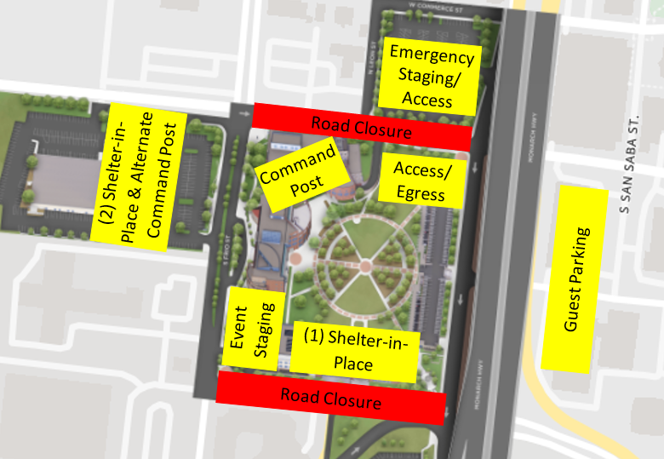
Operations [Insert screenshot/graphic of emergency logistics]

Critical Incident: In case of a critical incident such as an active shooter, explosive device detonation, found explosive device, or other major incident, the UTSA Police officers nearest to the incident will respond and SWAT and/or Bomb Squad personnel will be summoned to the scene. A “UTSA Alert” will be issued by emergency communication authorities as appropriate and university leadership will be immediately briefed by the Office of the Chief of Police. Decisions to evacuate UTSA property will also be determined in consultation with university leadership through the Office of the Chief of Police.
Police: The UTSA Police Department will be responsible for traffic control concerns for the event, prevent and address any criminal activity which may result in injury or major damage to property, along with providing general security and safety for all participants. The UTSA PD will provide a careful police response to various police situations while recognizing individual’s constitutional rights and supporting the university’s mission.
Medical: In the event of a serious accident, sickness, or injury, the nearest UTSA Police Officer will advise UTSA Dispatch with the incident location and severity of the injury. UTSA Police Officers will greet and guide arriving Emergency Medical Services (EMS) to the scene as needed. If transportation to the hospital is required, EMS will be dispatched.

APPENDIX 5: EVACUATION ASSEMBLY POINTS
[Insert screenshot/graphic of Evacuation Assembly Points for your area. Predetermined locations for buildings can be found on the Interactive Campus Map.]
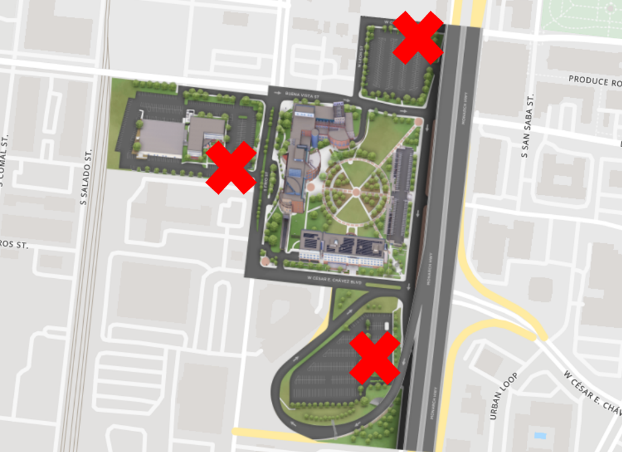

Evacuation Assembly Points (EAPs)
EAPs, in some instances, are not to be viewed as fixed locations due to changing circumstances of the surrounding areas and the environment (construction, obstructions, weather and wind direction, etc.). These are a list of things to keep in mind when selecting a location or locations for occupants to gather when your building is evacuated:
EAPs should be:
- Easily accessible; not a confined area.
- At a safe distance from the building (preferably 150 - 200 feet away).
- Away from secondary risk factors, such as dumpsters, gas mains or gas lines, high voltage wires or transfer points, and sewer main access covers.
- Uphill and upwind from building. Be aware that buildings can be evacuated due to hazardous materials release, fire and smoke, or potential incendiary device.
Try to Avoid:
- Blocking access routes or staging areas responders will use.
- Hydrants or utility shut-off valves / access points.
- Other risk/danger areas such as gas mains or gas lines, high voltage wires or transfer points.
- Channeling those who are evacuating into confined areas, such as tunnels and dead-ends or terrain that may cause people to trip. Both situations can cause crushing.
Also Consider:
- Those who are hearing, mobility and developmentally impaired and who may have special needs.
- Ways to account for those who have evacuated the building.
- Try not to position assembly points in areas where communications are impaired or not accessible.

APPENDIX 6: ADDITIONAL TRAINING RESOURCES

UTSA Classroom Training
Floor Captain Training: Click HERE
Safety Walk Through and Assessment: Click HERE
Responding to Evolving Active Campus Threats: Click HERE
HeartSaver First Aid, CPR and AED: Click HERE

Incident Command System Training
IS -100.HE: An Introduction to ICS or IS100.b: Introduction to Incident Command System
http://www.training.fema.gov/EMIWeb/IS/courseOverview.aspx?code=IS-100.HE
http://www.training.fema.gov/EMIWeb/IS/courseOverview.aspx?code=IS-100.b
IS-700: NIMS, An Introduction
http://www.training.fema.gov/EMIWeb/IS/courseOverview.aspx?code=IS-700.a
IS- 200: ICS for Single Resources and Initial Action Incidents
http://www.training.fema.gov/EMIWeb/IS/courseOverview.aspx?code=IS-200.b
IS-800.B: National Response Framework, An Introduction
http://www.training.fema.gov/EMIWeb/IS/courseOverview.aspx?code=IS-800.b
ICS-300: Intermediate ICS for Expanding Incidents
ICS-400: Advanced Incident Command
Search for these courses here: https://www.preparingtexas.org/index.aspx
Additional course opportunities:
https://www.preparingtexas.org/index.aspx

[The following are examples of additional attachments you may wish to include in Annexes]
- Security Plan
- Communication Plan
- Insurance Information
- Additional Policies
- Permits
- Location/Venue/Parking Maps
- Command Post Logistics
- Emergency Activation and/or Cancellation Protocol
- Emergency Messaging Scripts and/or Strategy

