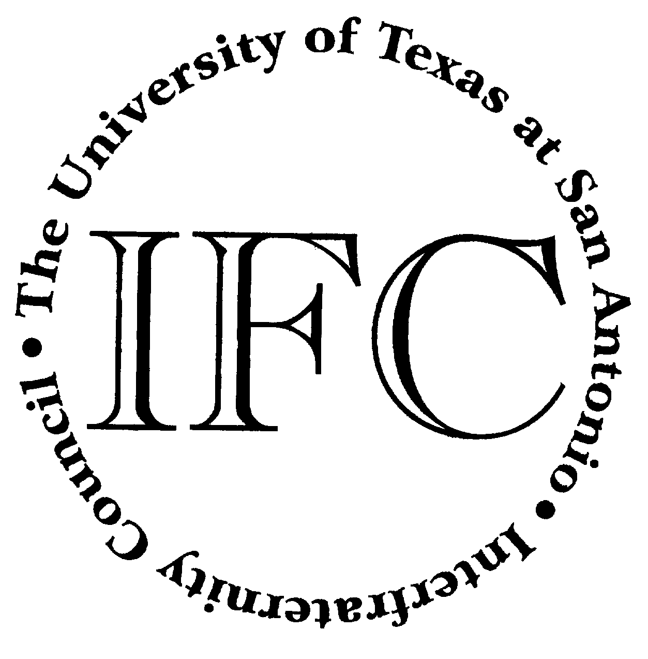
Student Activities Events For The Week Beginning April 16th
April 2nd – 27th
Fortune Cookie Contest
Learn the history of the Fortune Cookie,
Guess Correct # and win all the cookies!
Students Only Please
Durango Bldg. - Information Desk
All Day

Monday, April 16, 2007
Luau
An Asian Pacific Islander Month Event
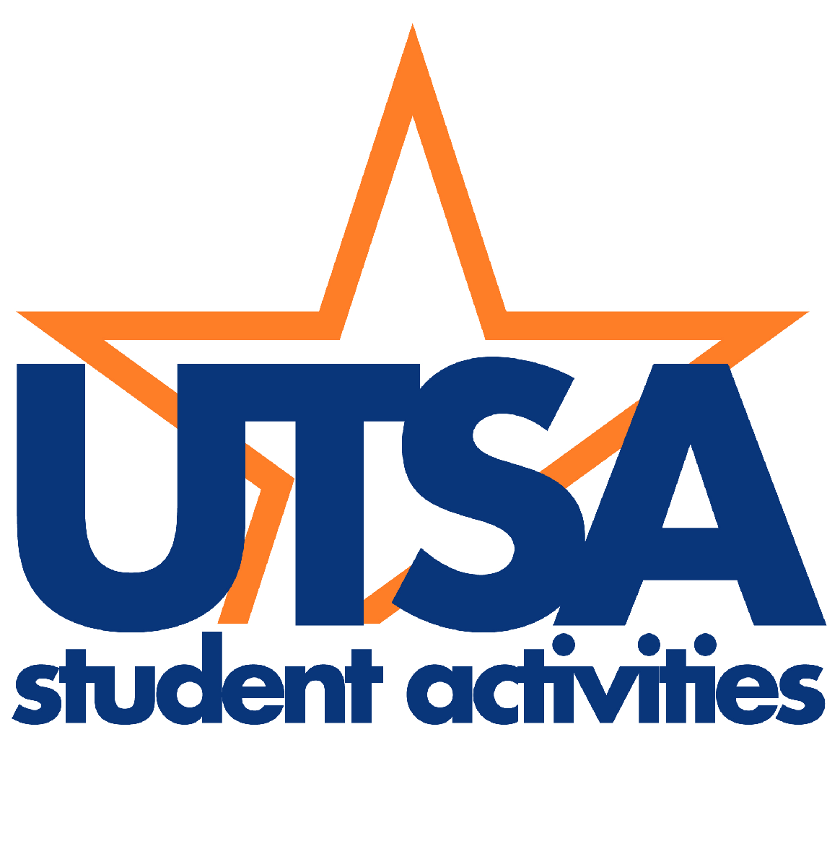
1604 Campus
University Center – Window Lounge
12 noon

Tuesday, April 17, 2007
Luau
An Asian Pacific Islander Month Event
DT Campus
Frio Street Commons
12:15pm

Wednesday, April 18, 2007
Movie Night: Stomp the Yard
Sponsored by CAB
1604 Campus
University Center- Retama Auditorium
7pm

Thursday, April 19, 2007
Matinee Movie: Stomp the Yard
DT Campus
Durango Bldg – Student Activities Center
12 noon

Friday, April 20, 2007
FIESTA UTSA
Caliente
Food, Entertainment, Royalty!
CAB Sponsors This Official Fiesta Event
1604 Campus
Sombrilla
11am – 3pm



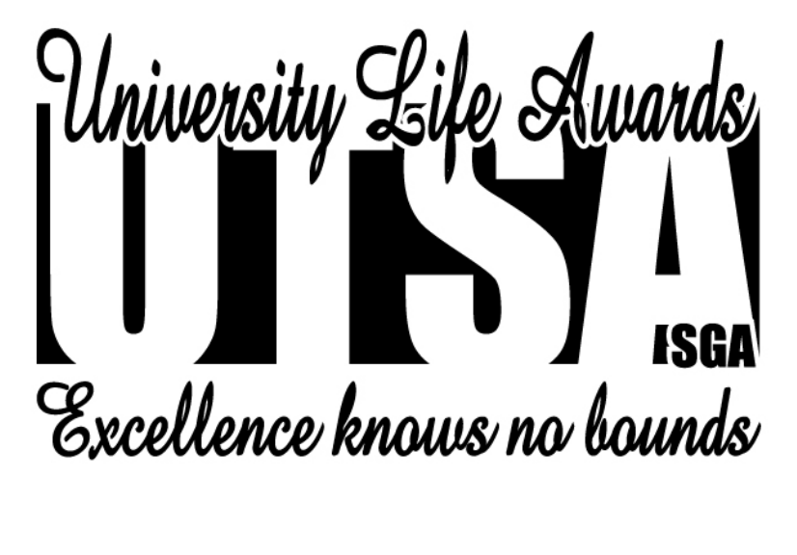April is Asian Pacific Islander Heritage Month

